**Client background:**

**Client name:** Social Buzz

**Client industry:** Social media & content creation

**Year established:** 2010

**Location of HQ**: San Francisco

**Number of employees:** 250

**Client background:** Social Buzz was founded by two former engineers from a large social media conglomerate, one from London and the other from San Francisco. They left in 2008 and both met in San Francisco to start their business. They started Social Buzz because they saw an opportunity to build on the foundation that their previous company started by creating a new platform where content took center stage. Social Buzz emphasizes content by keeping all users anonymous, only tracking user reactions on every piece of content. There are over 100 ways that users can react to content, spanning beyond the traditional reactions of likes, dislikes, and comments. This ensures that trending content, as opposed to individual users, is at the forefront of user feeds.

Over the past 5 years, Social Buzz has reached over 500 million active users each month. They have scaled quicker than anticipated and need the help of an advisory firm to oversee their scaling process effectively.

Due to their rapid growth and digital nature of their core product, the amount of data that they create, collect and must analyze is huge. Every day over 100,000 pieces of content, ranging from text, images, videos and GIFs are posted. All of this data is highly unstructured and requires extremely sophisticated and expensive technology to manage and maintain. Out of the 250 people working at Social Buzz, 200 of them are technical staff working on maintaining this highly complex technology.

Up until this point, they have not relied on any third party firms to help them get to where they are. However there are 3 main reasons why they are now looking at bringing in external expertise:

1) They are looking to complete an IPO by the end of next year and need guidance to ensure that this goes smoothly.

2) They are still a small company and do not have the resources to manage the scale that they are currently at. They could hire more people, but they want an experienced practice to help instead.

3) They want to learn data best practices from a large corporation. Due to the nature of their business, they have a massive amount of data so they are keen on understanding how the world's biggest companies manage the challenges of big data.

**Internal stakeholder chart**

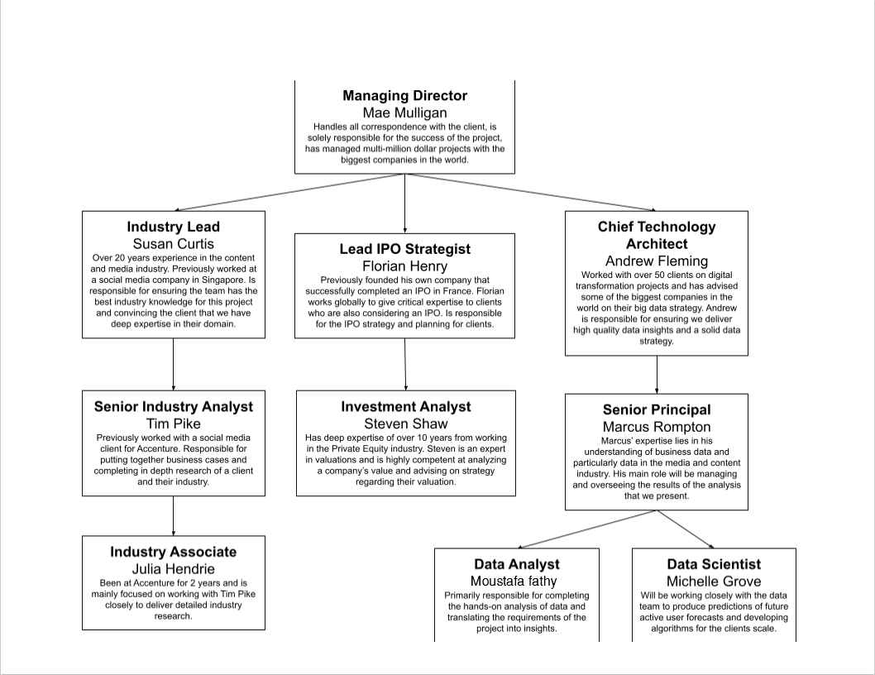

**My tasks:**

**Project understanding:**

the client stated that scale was a big problem of theirs and they are struggling to manage the scale with the resources that they currently have.

**Data modeling and cleaning:**

1. **Requirements gathering**

 fully understand the data model and how the tables link together. Then think about which tables are most relevant.

1. **Data cleaning**

removing columns that have a high number of missing values, removing rows that have values which are erroneous, changing the data type of some values within a column and also removing columns which are not relevant to this task. Your end result should be a set of relevant data sets that are clean with each data set containing only the columns which are relevant to the completion of this task.

1. **Data modeling**

use this knowledge to create a final data set containing all of the columns that you will need to complete the task.

**Data visualization and Storytelling**

use my data set to create insightful visualizations to address the requirements of the project (Matplotlip, Seaborn and Ploty libraries and Power BI tool)

**Present to the Client**